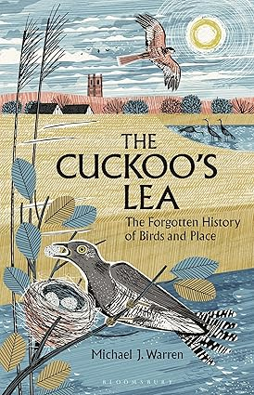
THE FRIENDS OF
THOMAS PLUME'S LIBRARY
invite you to a talk by Michael J Warren about his book: The Cuckoo's Lea: The Forgotten History of Birds and Place, which was a BBC Wildlife Best Book of 2025.

On Saturday 9th May 2026 at 7.30pm in The D’Arcy Room, All Saints Church, Maldon

Hidden in the names of English towns and villages, in copses, fields, lanes and hills, are the ghostly traces of birds conjuring powerful identities for people in ancient landscapes. What are their stories and secrets? How did people encounter birds over a thousand years ago? Michael will talk about how he set out on the trail of these ghosts. Captivated and guided by the secrets of place names, their stories are entangled with his own explorations of places through birds all across England. Maldon Books will have copies of Michael’s book for sale at the event.
There will be a short AGM beforehand. A glass of wine/soft drink and light refreshments will be available in the interval. Entry is free. We hope you will join us!
Registered charity no. 1098311

