THE FRIENDS OF THOMAS PLUME’S LIBRARY
Registered charity no. 1098311
Market Hill
Maldon CM9 4PZ
Email: friendsofplumelibrary@gmail.com

April 2026

Dear Friends
Welcome to our April newsletter in which we bring you up to date with recent activities, future events and Library news. But first some admin!

Subscription and membership payments
For many years (probably since the Friends was formed in the 1980s) our subscription has been £5 a year, which many people generously supplement with a donation. In view of rising costs, the Friends’ committee plans to put a motion to our AGM to increase this amount to £10. If approved, the increase will not take place until April 2027, and our subscription remains at £5 for this year.

Many of you pay your subscriptions by standing order which we prefer, as it means we have a reliable annual income. For those of you who pay by cheque each year, please note that we are now being charged for each cheque we pay in to our bank. It would be very helpful if you are able, to pay online by bank transfer or to set up a standing order.

Recent activities
Our annual quiz took place on Saturday 7 February and was a great success thanks to our quizmaster, Frank Garcia setting such novel and interesting questions. Unfortunately, the night we picked coincided with some of our regular supporters being away, so that we were a few less than normal. Nevertheless, we added £701 to our fund for replacement book purchases.

Future events
Our AGM takes place on Saturday 9 May at 7.30pm in the D’Arcy Room at All Saints Church, Maldon. After our AGM business, which is usually very brief, and some refreshments, Michael J Warren will talk about his recent book The Cuckoo’s Lea. This looks at the ghostly traces of birds hidden in the names of English towns, villages, copses, fields, lanes and hills and was a BBC Wildlife Best Book of 2025. Copies of Michael’s book will be available to buy during the evening.

We are very sorry to let you know that our summer outing, which usually takes place in June or July has had to be postponed. We had a venue lined up but, unfortunately, they had to cancel at the last minute, which has not left us time to organise an alternative. We hope to be able to put together an outing for early autumn and will let you know when information is available.

Heritage Open Day will be on Saturday 12 September when the Library will be open to visitors all day. As usual we will be looking for volunteers from among the Friends to steward in the Library and to regulate the flow of visitors at the door. This year we have decided not to run our Friends’ bookstall, but will be providing an information stand about the Friends in the Library grounds and running a raffle.
News from Dr Helen Kemp, the Plume Library Keeper
We are grateful to the Friends for funding the purchase of the following books:
- Thomas Scott, Philomythie or philomythologie wherein outlandish birds, beasts and fishes, are taught to speak the English plainely. 1616;
- Joachim Camerarius, Symbolorum et emblematum ex re herbaria desumtorum centuria, 1590;
- Plato, Opera Gr. Lat. Cum versione, argumentis & comment. Mars. Ficini. Franc. 1602.
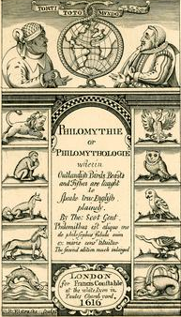 | 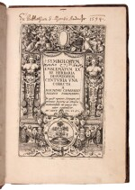 | 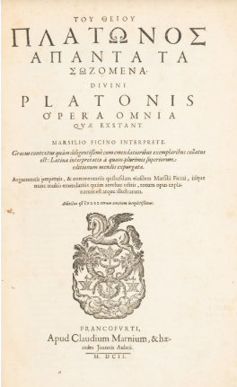
Research enquiries and visits
We had a visit at the end of October from a Fellow at Cambridge who wanted to know whether we had any “obliterated signatures” of previous owners. Luckily, due to the hard work of Friends’ volunteers on the book inventory I was able to show her 59 books where the previous owner’s name had been obscured in some way.

Simon Proctor, Chairman of the London Library, visited on 27 November. The London Library is also a member of the Independent Libraries Association, and he is endeavouring to visit each of the member libraries to see the variety of spaces and contents, and how each institution operates financially and practically
We received an enquiry from a local resident who is interested in our holdings relating to the Maldon Puritan preacher George Gifford (1548-1600). Plume knew Gifford’s son and grandson. The researcher came to the Library in March to see the five Gifford books Plume owned.
We had a student visitor on 17 February who is writing her undergraduate dissertation on medieval Maldon, and wanted to study some books about Beeleigh Abbey. We also had a postgraduate student visitor on 4 March, who wants to write an essay on Plume’s collecting practices. She is hoping to return soon to study some of the collection, once she has an idea of her theme.
Conservation Projects
We put out an appeal to the Friends last summer for conservation funding for the book Historia Navalis, which included repair of the fold out image, which features on our tote bag. Several friends replied offering to fund the repair and digitisation. The first person who replied paid for the conservation work and the others were offered first refusal on funding more conservation work.
Publicity and Merchandise
Our Rhinoceros jigsaw has been popular, with the first batch of 13 all sold within a week. Another 11 copies of this design are now available to purchase. They are priced at £20 each.
Further to the Friends’ trip to Milton’s Cottage last summer, we have borrowed their idea of a booklet of “Thomas Plume’s Library in 12 books”, which our assistant Library Keeper Phoebe has created. These booklets are priced at 99p each. Phoebe has also put together another booklet (four double-sided pages this time), which comprises a tour of the Library through the main objects in each room. This costs £3 due to the extra printing and content.
During the May half term (25-31 May) we will have an exhibition about “Norman History”. The Library will be open during normal hours.

Yours sincerely,
Sue Edward
On behalf of the Committee of the Friends of Thomas Plume’s Library

