CHARITY GIFT AID DECLARATION
Boost your donation by 25p of Gift Aid for every £1 you donate.
Gift aid is reclaimed by the charity from the tax you pay for the current tax year. Your address is needed to identify you as a current UK taxpayer.

In order to Gift Aid your donation (including your subscription) please tick the box below:
I want to Gift Aid my donation of £................ and any donations I make in the future or have made in the past 4 years to The Friends of Thomas Plume’s Library.
I am a UK taxpayer and understand that if I pay less Income Tax and/or Capital Gains Tax than the amount of the Gift Aid claimed on all my donations in that tax year it is my responsibility to pay any difference.
Title........ First Name............................. Surname...........................................
Home address..................................................................................................
..................................................................Post Code.......................................
Signed................................. Date..............................

Please notify the Friends of Thomas Plume’s Library, by contacting the Membership Secretary, if you:
- Want to cancel this declaration;
- Change your name or home address; or
- No longer pay sufficient tax on your income and/or capital gains.
If you pay Income Tax at the higher or additional rate and want to receive the additional tax relief due to you, you must include all your Gift Aid donations on your Self-Assessment tax return or ask HM Revenue and Customs to adjust your tax code.

Data protection
Your details will be processed fairly and lawfully in order to satisfy the agreement entered with you on your admittance to membership. This will ensure that you receive all the latest news and information about the Library and forthcoming events and outings. Your details will not be passed on by us to any other organisation unless we have your specific consent. We may, however, contact you from time to time with items of information that we believe may be of interest to you. Our Data Privacy Notice may be found at: http://www.thomasplumeslibrary.co.uk/fotpl
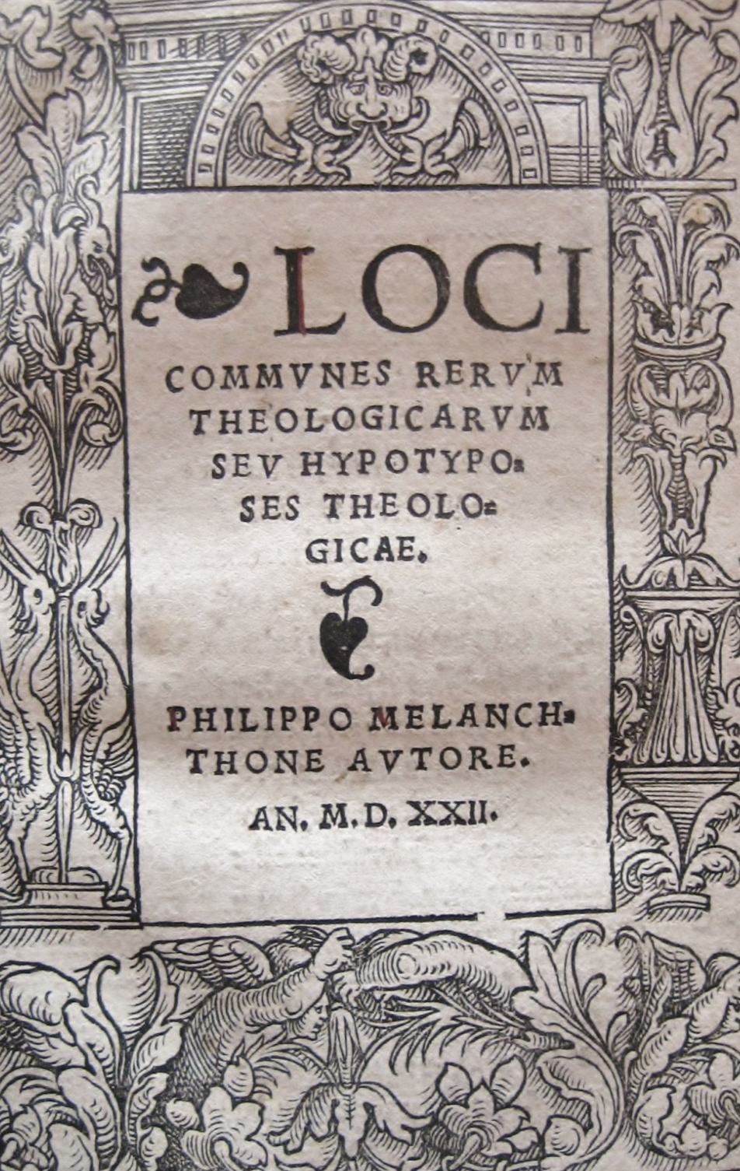
Join the
FRIENDS
OF
THOMAS
PLUME’S
LIBRARY
Maldon
THE FRIENDS OF THOMAS PLUME’S LIBRARY
Registered charity 1098311
For just over 300 years, Maldon has housed a treasure whose significance stretches far beyond the Essex town. Thomas Plume’s Library, left to Maldon by a grateful native and leading churchman, is one of the largest and most interesting collections of books of its time still to survive in the building erected to house it.
St Peter’s Tower is all that remains of an ancient church in the centre of Maldon. Dr Plume funded the rest of the building to provide a grammar school and a home for his book collection upon his death in 1704. The Library’s handsome panelled room, approached by a narrow spiral staircase, provides a magical setting for over 7,000 leather-bound volumes – but it is not merely a tourist attraction. The books continue to be of value to researchers who may visit it on Tuesdays, Wednesdays and Thursdays from 2-4pm; and Saturdays from 10am to 12 noon.
The Friends of Thomas Plume’s Library was formed in 1988 to help the Library’s Trustees preserve this Maldonian gem in a good state for future generations. The Friends raise funds for repair and renovation of the books, but above all, to help find and acquire replacements for 16th and 17th century works that have been lost since the Library was formed. Over 160 titles have been found so far, but many more are needed to bring Dr Plume’s bequest back to its original size.
Front page:
Woodcut border from the title page of
‘Loci Communes Rerum Theologicarum’
By Philipp Melanchthon 1522.
Purchase funded by the Friends of Thomas Plume’s Library to replace the copy missing from the original collection, March 2014

Please note that unless you state otherwise our twice-yearly information to Friends will be sent to you by email. Please print your email address accurately and legibly, if applicable.

If you are interested in this historic collection and would like to help us to preserve and enhance Thomas Plume’s Library, you can become a Friend for only £5 a year – though of course we welcome additional donations.

Please complete your personal details:

Title........... First Name.............................Surname..................................................
Home address............................................................................................................
...................................................................................................................................
Postcode............................Email address..................................................................
Telephone...................................................Date.......................................................
Ways to pay your subscription:
Standing order: Please use the bank details below to set this up with your bank. This reduces the administration for you and for our Treasurer. You can cancel the annual standing order at any time.
Lloyds Bank: Account name: The Friends of Thomas Plume’s Library;
Sort code: 77-13-20; Account number: 69993868
Please then email this completed form to friendsofplumelibrary@gmail.com
Bank transfer: Please use the bank details above to make a payment direct to our account then email this completed form to friendsofplumelibrary@gmail.com
Cheque: Please send your cheque payable to The Friends of Thomas Plume’s Library together with this completed form to our Membership Secretary: Sue Edward, 7 Highfields Mead, East Hanningfield, Chelmsford, CM3 8XA.

- *I/we wish to contribute by Standing Order and have instructed my/our bank to make an annual payment of £………..
- *I/we have paid £………. by bank transfer
- *I/we enclose my/our subscription of £……….. (£5 per person due 1 April each year)
- *I enclose an additional donation of £……….
*Please delete as appropriate

To boost your donation by Gift Aid please see overleaf. Thank you for your support.

