The Plume Lecture 2026
Thomas Plume’s Library

Invites you to attend an interview with: Simon Heffer Baron Blackwater, who has had an interesting and varied career as a journalist, political commentator, and historian. He is the author of many books on the social history of Great Britain from the mid-19thc until the end of WW1, including several biographies.
Photo Credit: Essex Book Festival
Friday 11th September at 7pm at The United Reformed Church, Market Hill (doors open 6.30).
Entry free, donations welcome!
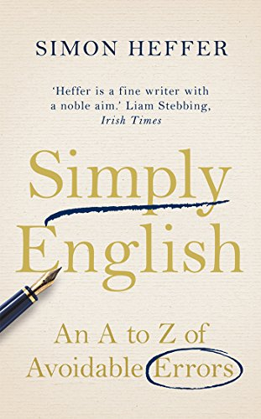 | 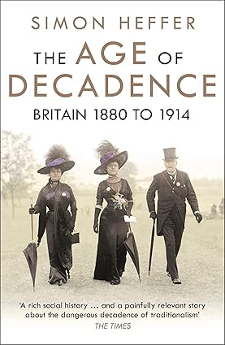 | 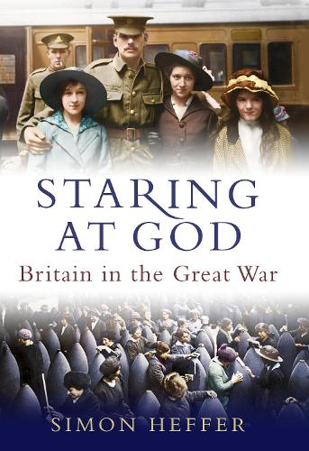 | 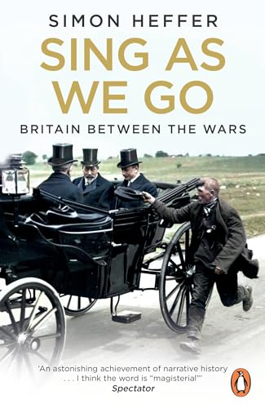 | 

